**Ideation Phase**

**Define the Problem Statements**

|  |  |
| --- | --- |
| Date | 19 September 2022 |
| Team ID | PNT2022TMID36201 |
| Project Name | Smart Waste Management System For Metropolitan Cities |
| Maximum Marks | 2 Marks |

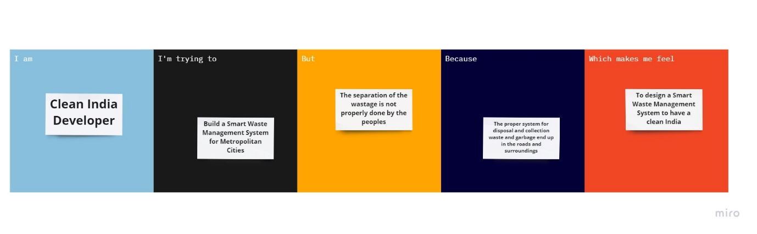

|  |  |  |  |  |  |
| --- | --- | --- | --- | --- | --- |
| **Problem Statement (PS)** | **I am** | **I’m trying to** | **But** | **Because** | **Which makes me feel** |
| PS-1 | Clean India Developer | Build a smart waste management system for metropolitan cities | The separation of the wastage is not properly done by the peoples | The proper system for disposal and collection of waste and garbage end up in the roads and surroundings | To design a smart waste management system to have a clean India |